“And the peace of God, which surpasses all comprehension, will guard your hearts and your minds in Christ Jesus.” -- Philippians 4:7
- Please show all your work! No partial credit will be given for incorrect answers with no work shown. Please draw a box around your final answer.
- Calculators are permitted, but no notes, text, laptops, PDAs, or electronic dictionaries.
- Cell phones should be muted and left in your pocket or bag.
Total marks: 130

- 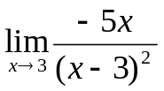 [3]
-∞
- 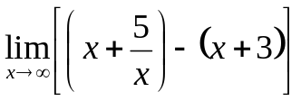 [3]
-3
- 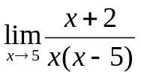 [4]
Does not exist
- 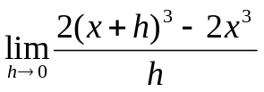 [4]
6x²
- Let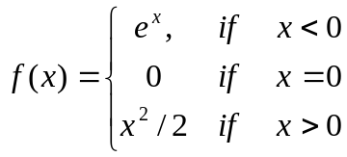.
  - 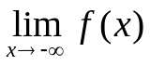 [2]
0
  - 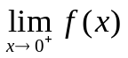 [2]
0
  - Is f(x) continuous at x=0? [3]
No
- 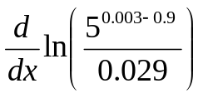 [2]
0
- 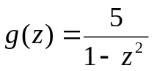. Find g’(z). [4]
10z / (1-z²)²
- 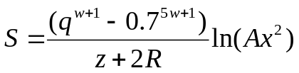. Find dS/dq. [3]
(w+1) q^{w} ( 1/(z + 2R) ) ln(Ax²)
- Find dy/dz if 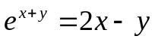. [4]
( 2 – e^{x+y} ) / ( 1 + e^{x+y} )
- Let 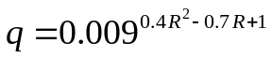.
Find dq/dR. [5]
ln(0.009) (0.8R – 0.7) *
0.009^{0.4R^2 – 0.7R + 1}
- 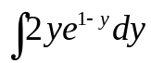 [6]
-2e^{1-y} (y + 1)
- 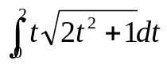 [4]
(1/6) (2t² + 1)^{3/2}:
13/3
- 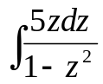 [4]
-(5/2) ln |1 – z²| + C
- Solve: 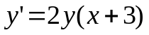. [5]
y = e^{(x+3)^2 + C}
- 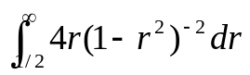 [5]
8/3

- Let f(x) = 2^{x}. Find f⁽¹⁰⁾(x) (the tenth derivative!). [4]
(ln2)¹⁰ 2^{x}
- Let f(x,y) = e^{xy}. Find all four second derivatives. [5]
d²f/dx² = y²e^{xy}
d²f/dy² = x²e^{xy}
d²f / dxdy = d²f / dydx = xye^{xy}
- Consider 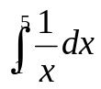.
  - Solve the integral using regular integration. [2]
ln(5) ≈ 1.609
  - Approximate the integral using Simpson’s rule with n=4 intervals (Δx=1). [4]
(1/3) ( 1/1 + 4(1/2) + 2(1/3) + 4(1/4) + 1/5 ) ≈ 1.622
  - What is the error in the approximation using Simpson’s rule? [1]
1.622 – 1.609 ≈ 0.013
- Use Newton’s method to approximate 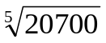 (hint: it is the root of 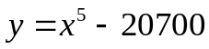). Start with an initial guess of x₀ = 15 and show two steps (find x₁, x₂). [6]
f’(x) = 5x⁴
x₁ = x₀ – f(x₀) / f’(x₀)
= x₀ – (x⁵ – 20700) / 5x⁴
= 15 – (15⁵ – 20700) / 5(15)⁴
≈ 12.082
x₂ ≈ 9.860
(the real answer is ≈ 7.2978)
- Find the area bounded by the curves y = e^{x/2}, y = 1, and x = 2. [4]
2e – 2
≈ 3.437
- If 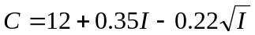 is a consumption function, find the marginal propensity to save when I=4. [4]
dC/dI = 0.35 – 0.11/√I
dS/dI = 1 – dC/dI = 0.65 + 0.11/√I
= 0.705
- The demand equation for a product is 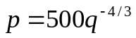.
  - What is the price when q=1000 units are demanded? [1]
p = $0.00
  - Find the point elasticity of demand when q=1000. Is the demand elastic? [5]
-3/4: inelastic
  - What is the marginal revenue when q=1000? [4]
-1/60 ≈ -$0.01667 per unit
  - A total of m employees can produce q = 50 m^{1/2} units. How many employees are needed to meet the demand of q=1000 units? [2]
m = 400
  - Find the marginal-revenue product at the current demand of q=1000 units. [3]
(-1/60) (5/4) = -1/48 ≈ -$0.020833
- Consider the function 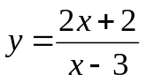.
  - Find all x and y intercepts. [2]
(0, -2/3), (-1, 0)
  - Find all vertical and horizontal asymptotes. [2]
Vert: x=3. Horiz: y=2
  - Find all zeroes and discontinuities of the function. [2]
x = -1, 3
  - On what intervals is the function positive? Negative? [2]
(-∞, -1): +. (-1, 3): –. (3, ∞): +
  - Find the first derivative dy/dx. [3]
dy/dx = -8 / (x-3)²
  - Find all critical points. [2]
x = 3
  - On what intervals is the function is increasing? Decreasing? [2]
Always decreasing
  - Find the second derivative d²y/dx². [3]
d²y/dx² = 16 / (x-3)²
  - Find all inflection points. [2]
None (discontinuity at x=3)
  - On what intervals is the function is concave up? Concave down? [2]
Always concave up

